# **Take and Make: Number Slider**

Lauren Siegel

January 2, 2020

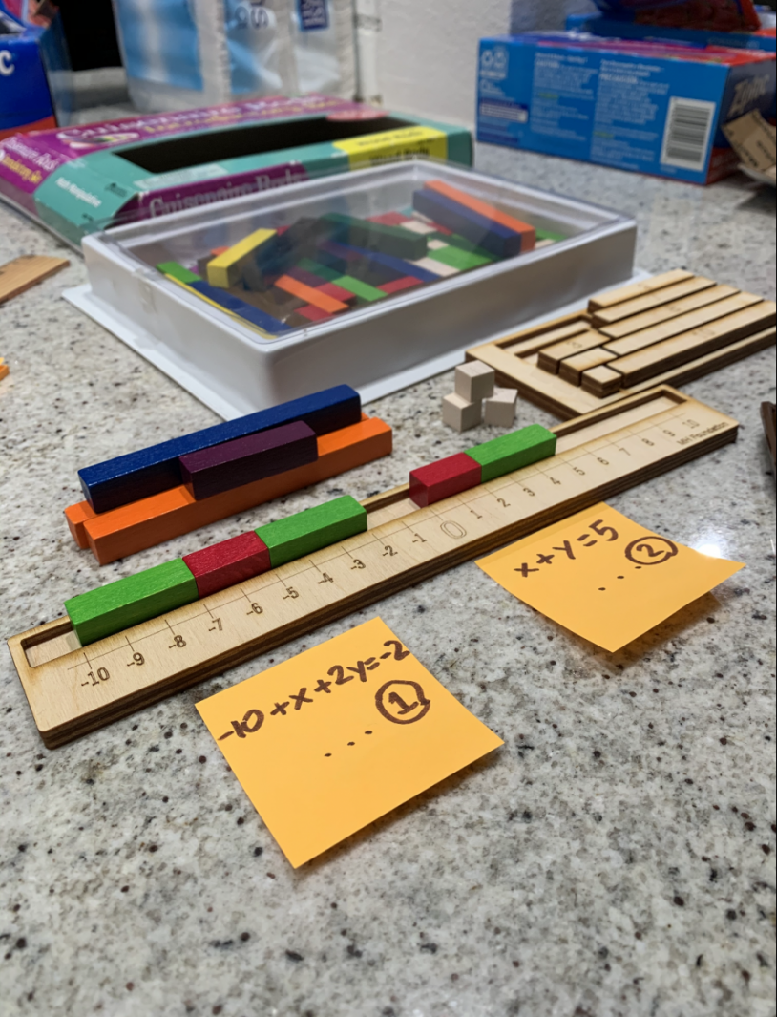

This is a great project. Viyang Shah shows how you can expand from just adding and subtracting. Happy Making!

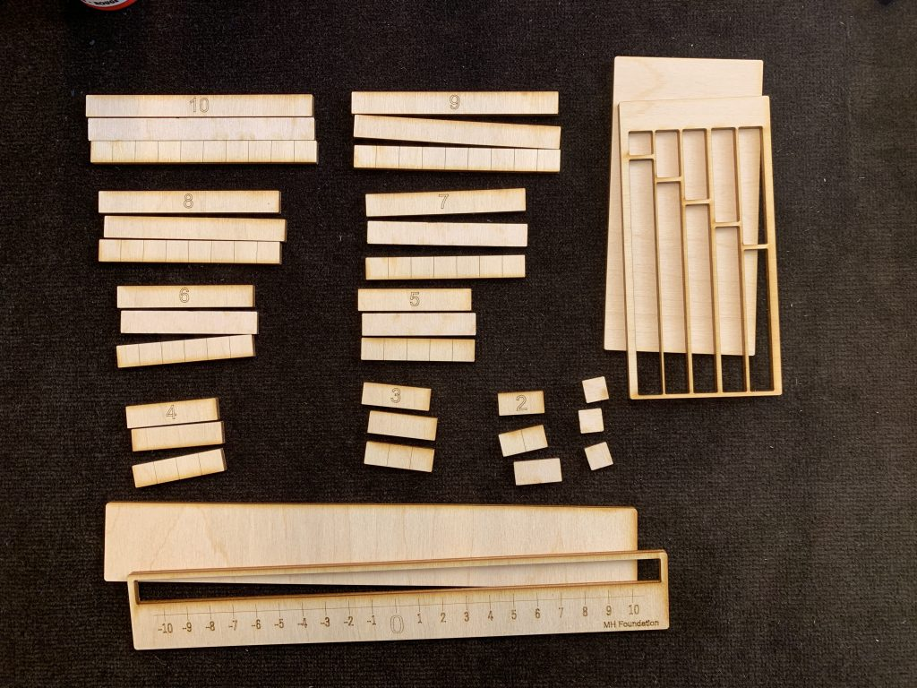

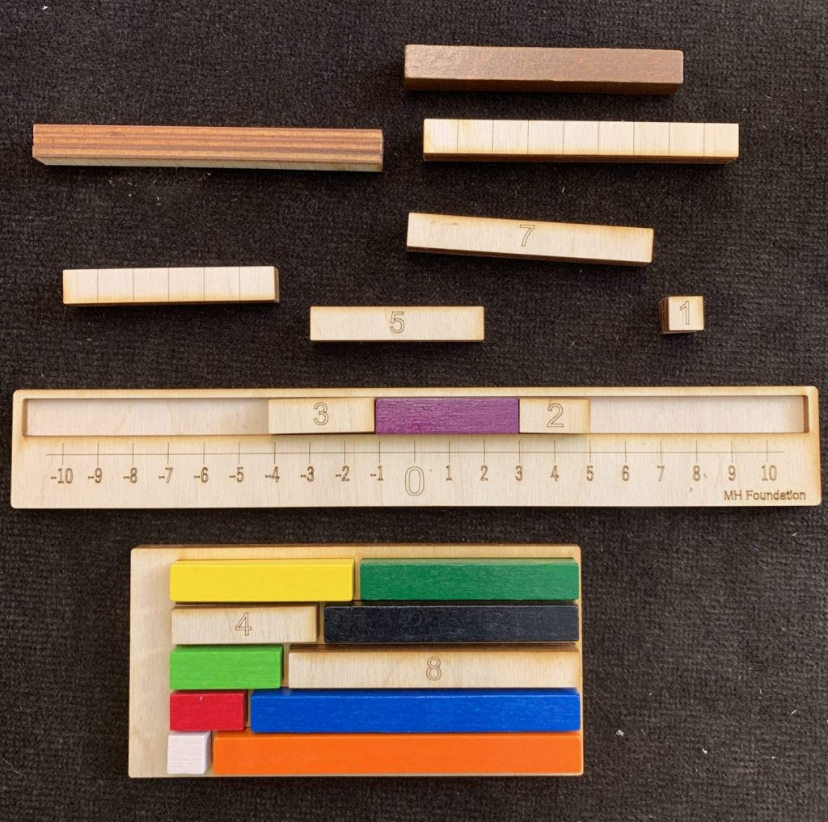

First version by Paola Garcia. Improvements and Cuisenairre adaptations based on suggestions from Jo Boalers facebook group YouCube completed in Fall 2019.